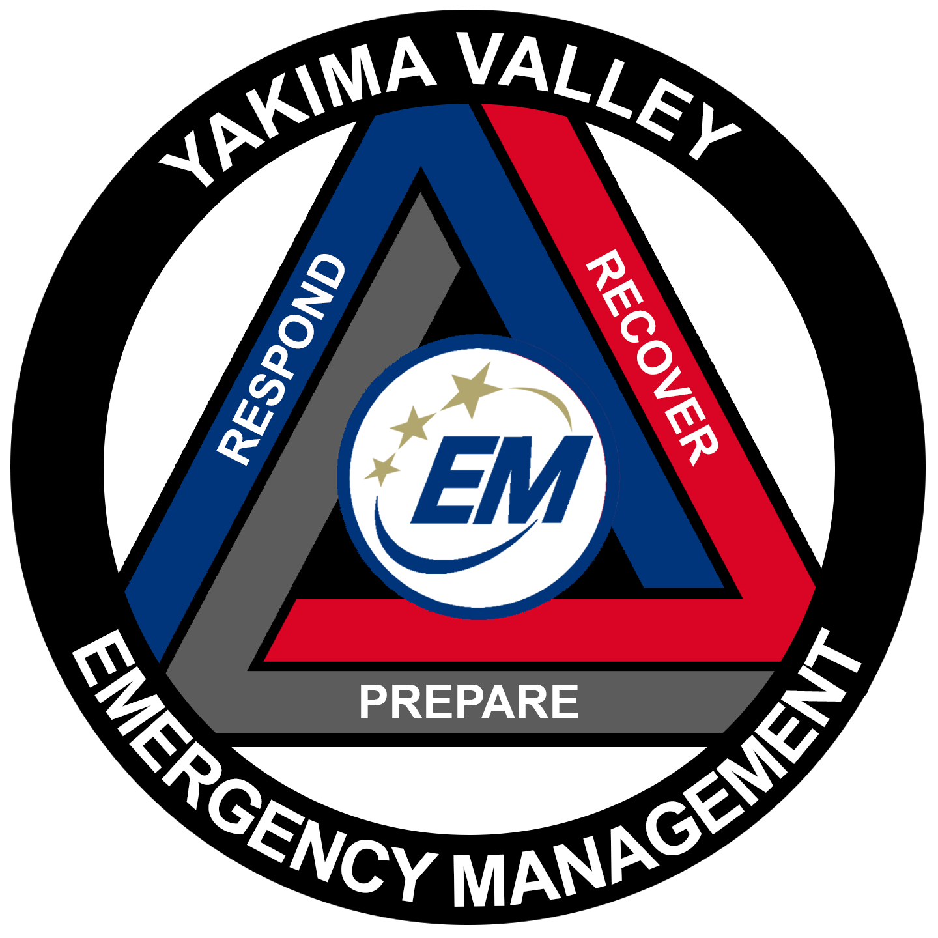
Yakima Valley Emergency Management
Situation Report: #1
Incident: [Name & Town]
YVEM Incident #: [Found in events list]
SEOC Incident #: [Found by calling/emailing SEOC]
Member Jurisdictions Impacted: Yakima County, [enter any additional cities]

Prepared By:
Report Period:

Summary of Incident: [should outline high level, key pieces of information about the incident. This narrative should grow throughout the incident so the last SitRep has a full summary of the incident] [DELETE all text in brackets; DELETE ESF’s with no data. After 1st sitrep mark any changes with yellow highlighting]

Current Acres: 0 acres
Fire Containment: 0%
Structure Loss: 0
[Change data points based on hazard, flood, fire, winter storm, etc. Delete if not needed]

ESF # 1 - Transportation
- Road Closures:
- [any other impacts to transportation: destruction of major roads, impact to airport, etc]

ESF # 2 - Communications
- [impacts to communication infrastructure, public services communications, private industry]
- [Activation of ARES/RACES staff and locations]

ESF # 3 – Public Works
- [snow plowing operations and any other public works functions being undertaken]
- [Dams/ ACE related info]

ESF # 4 - Firefighting
- [firefighting efforts, ground crews, air ops]
- [details on state mobe or FMAG]

ESF # 5 – Emergency Management
- [OEM status: Monitoring, Scene, EOC activated]

ESF # 6 – Mass Care
- [Shelters opened/locations]
- [comfort center locations]

ESF # 7 – Logistics
- [Major logistics information such as large logistics nodes operating]
- [Donations management operations underway]

ESF # 8 – Public Health and Medical
- [Public health warnings]
- [medication dispensing operations]
- [Issues with hospitals or ambulance companies]
- [MCI information]

ESF # 9 – Search and Rescue
- [Major SAR operations underway]

ESF # 10 – Hazardous Materials
- [Major Hazmat operations underway]
- [CGS/Hanford actions]

ESF # 11 – Agriculture
- [Impacts to crops/livestock]
- [Actions being undertaken around agriculture outreach, monitoring, etc]

ESF # 12 – Energy
- [Large power outages]

ESF # 13 – Public Safety and Security
- [Evacuation notices in place]
- [Police operations underway]

ESF # 14 – Long Term Recovery
- [Recovery Plans]
- [State of IA/PA declarations]

ESF # 15 – Public Information
- [Who is handling public information/location of JIC]
- [Major points of public concern]

Disaster Declarations: None

Planned Future Actions
- [list of planned future actions, 3-5 actions]

Next Situation Report: [Day, date, and time]

