Herbicide Recommendations
For Noxious weed control
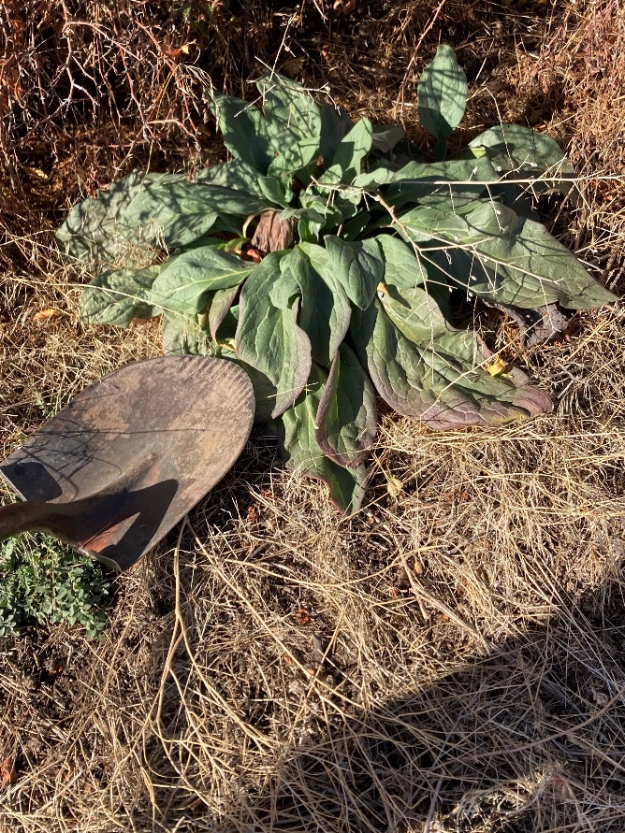
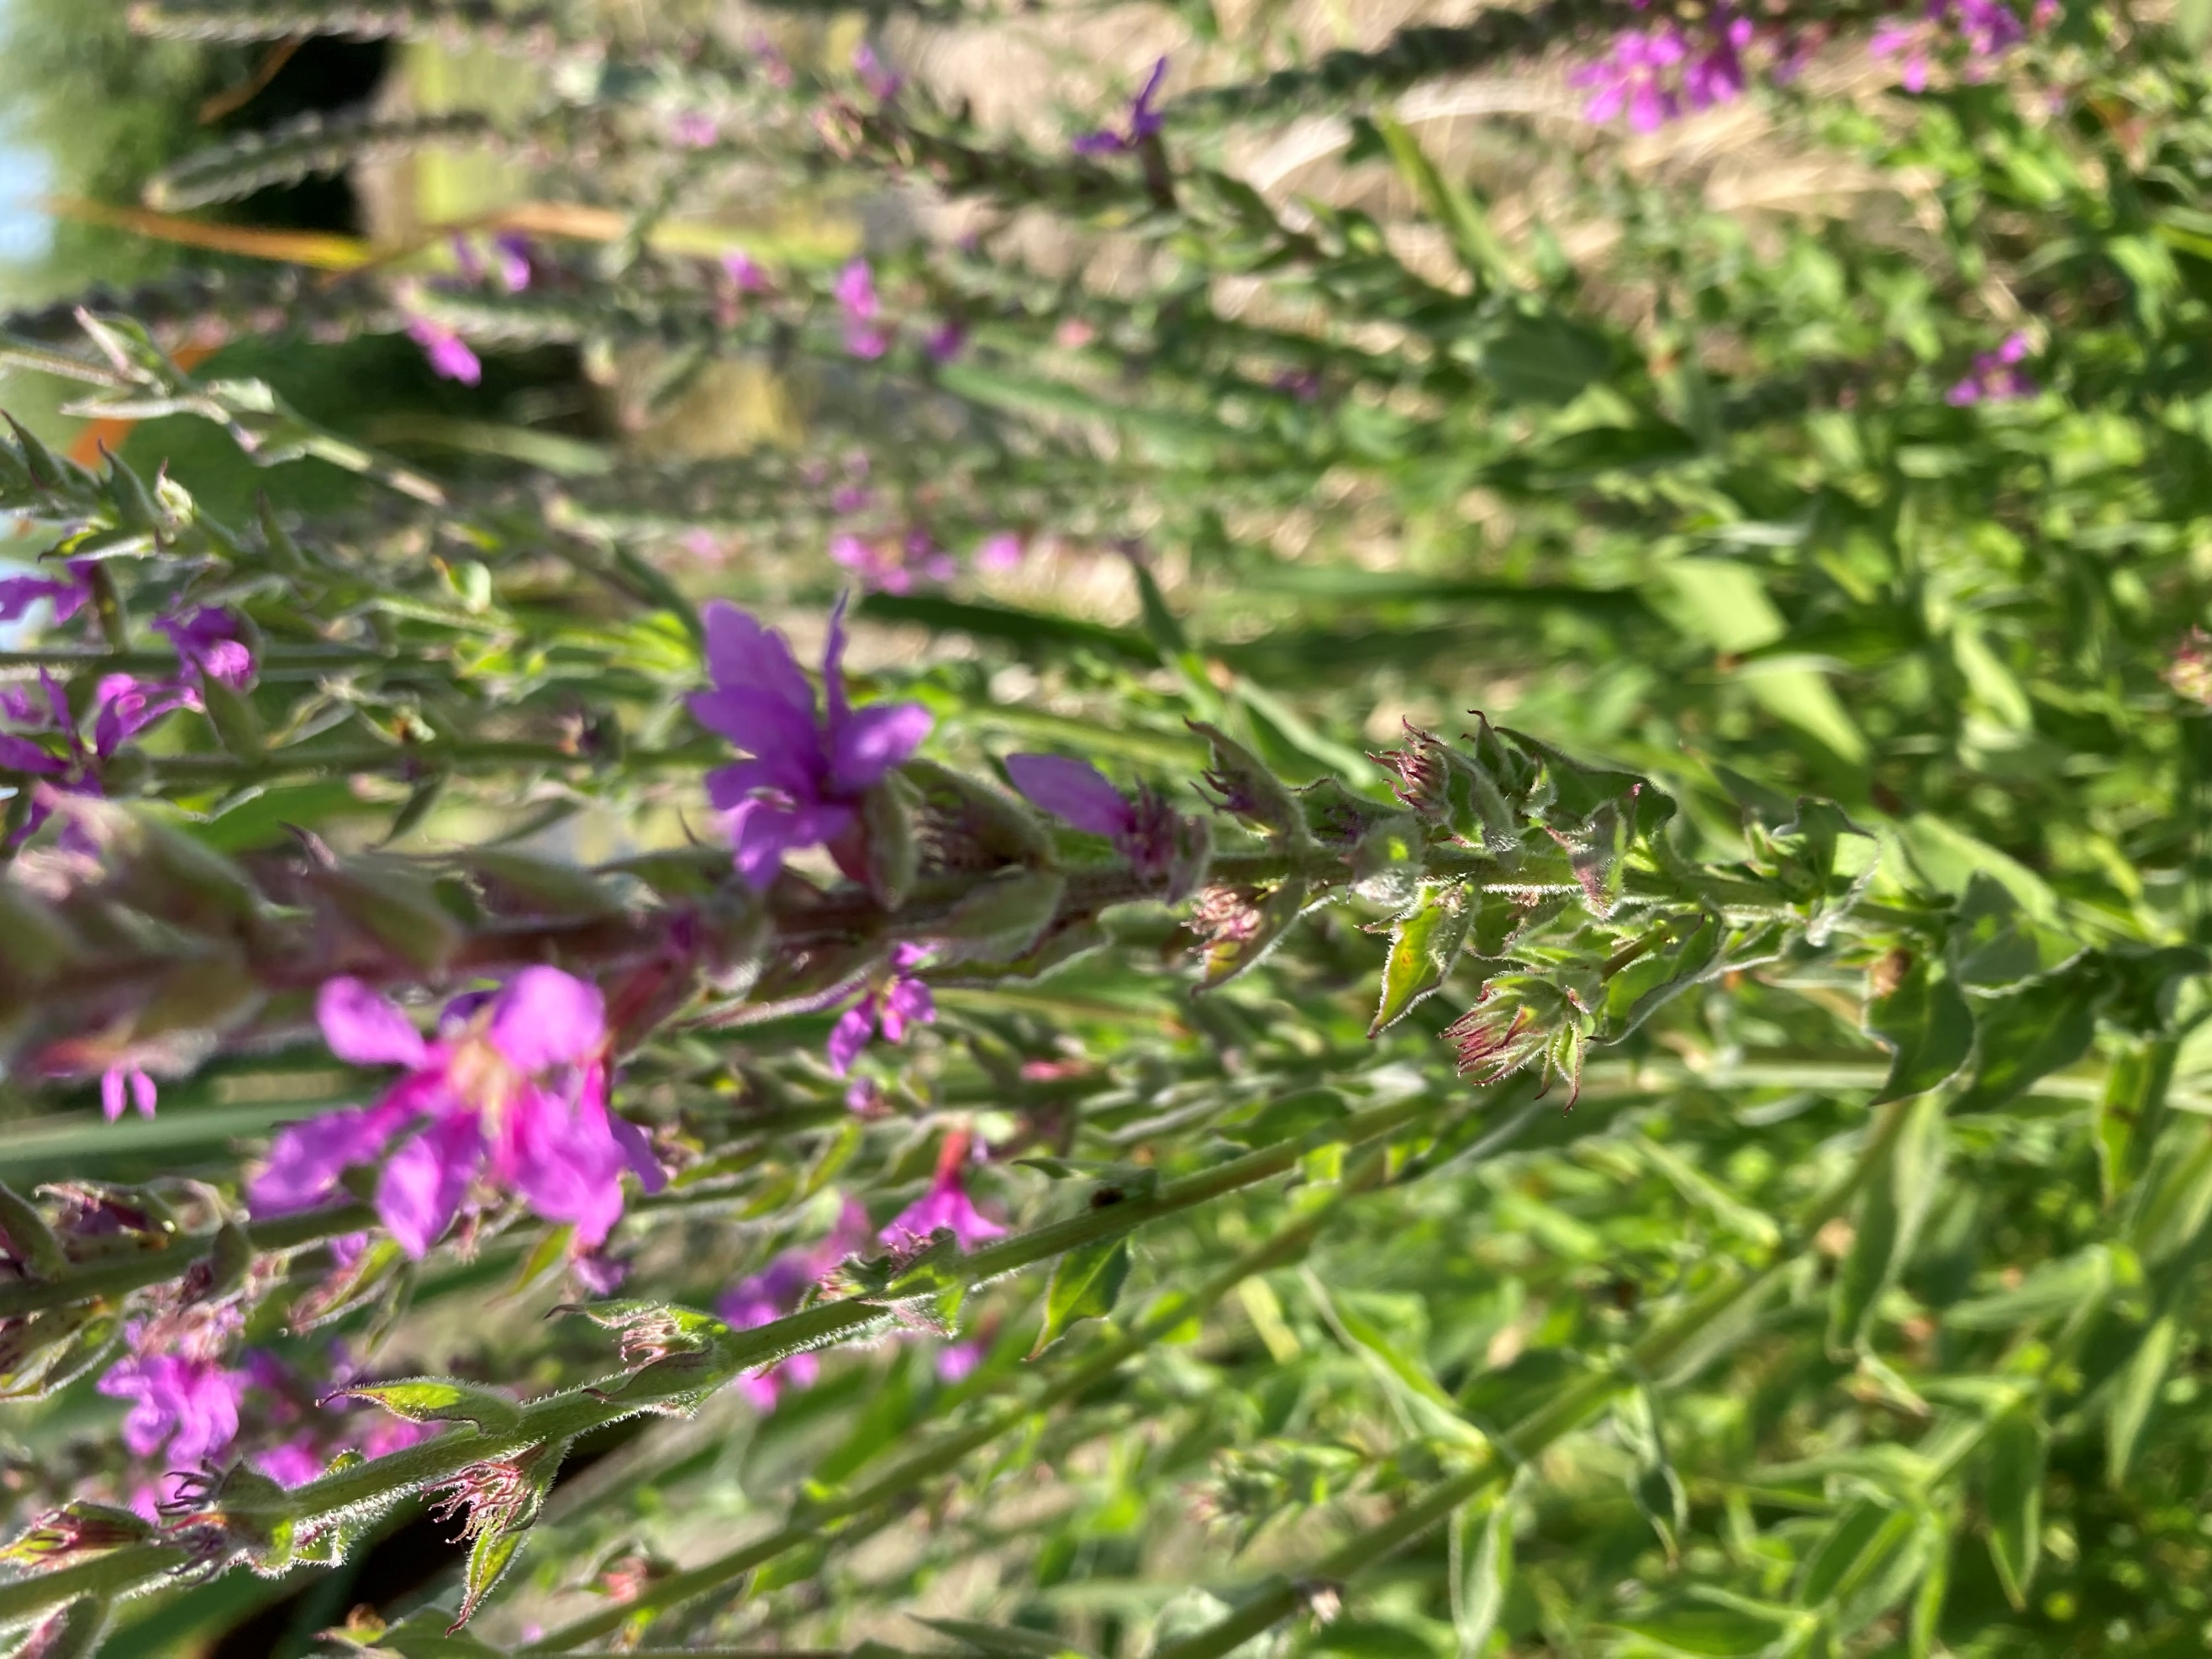
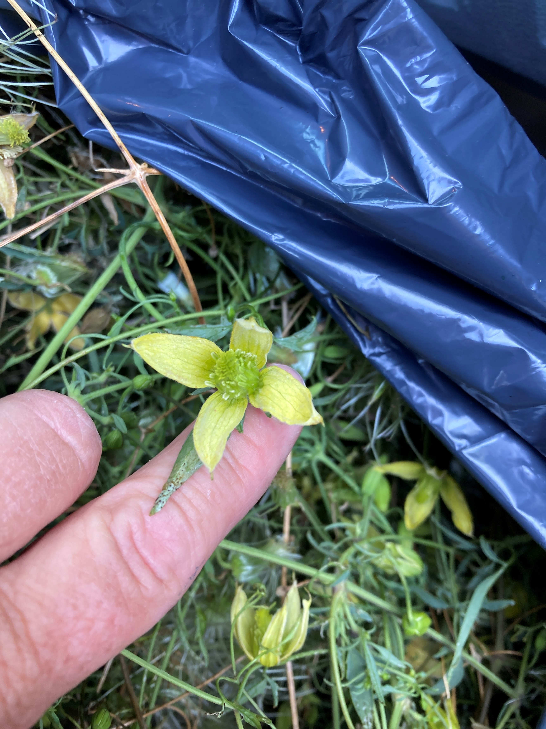

Before spraying herbicides, check out:
- What herbicides are recommended?
- When should I spray?
- Should I be using an MSO surfactant?
- What chemicals work best on each weed?
- What other control options are there?
- Are there other cautions I should be aware of?

Table of Contents: 2
Some services provided by the Weed Board 3
What is a Restricted Use Pesticide? 4
Getting a Pesticide Applicators License 4
Herbicides, their Chemical Names 8
Calibrations, Conversions, and Measurements 11
What should you do after spraying? 12
Are Herbicides Poisonous? 12
Where do you Purchase Herbicides? 13

Services Provided by the Weed Board:
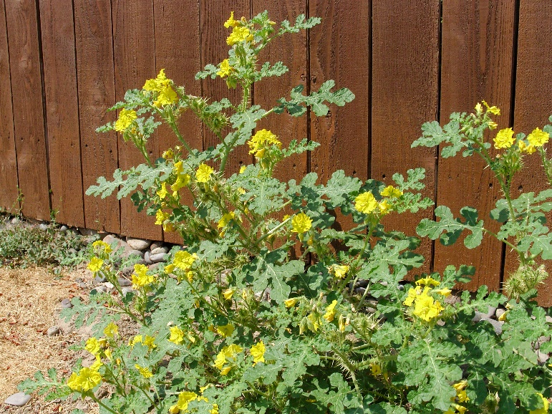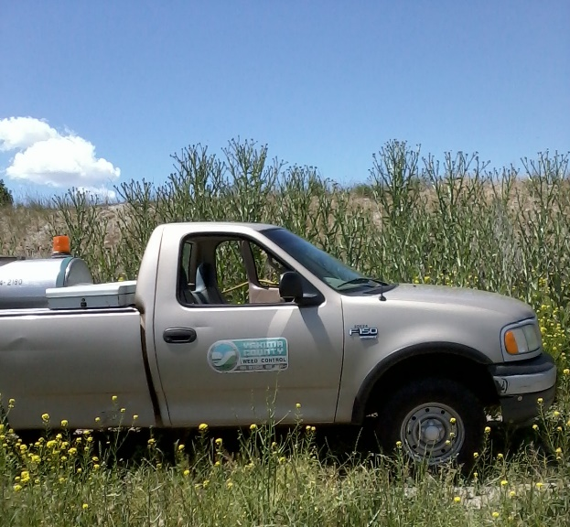
-Landowners are responsible for controlling noxious weeds on their property per RCW 17.10
-The Weed Board provides technical assistance: photo cards, information, brochures, and pamphlets to assist landowners in controlling problem weeds.
-Weed Board Staff will meet with landowners on their property for field walks, weed ID, and to make recommendations for control.
-Weed Board Staff maintains a list of commercial companies that work with -landowners, available to facilitate weed control on landowners’ property, this is especially beneficial to absentee landowners.
-The Weed Board Loans equipment at no cost! We have 15-gallon electric tanks and 50-gallon, 100-gallon, & 300-gallon PTO tanks. We do require a $100.00 Deposit (check only) that is fully refundable when equipment is returned in the same condition as checked out.
If you have a class A weed, the Weed Board will treat it at no cost to landowners!
-Herbicide Grant Cost share program for designated class B Noxious Weeds:
Yellow Starthistle, Scotch Thistle, Musk Thistle, Spotted & Meadow Knapweed,

Getting a Pesticide Applicator’s License:
What are the advantages?
- ability to purchase larger quantities of herbicide / pesticide
- can purchase and use “restricted-use” herbicide / pesticides
-- better/stronger product, longer lasting, less labor over time…
- some of the active ingredients found in Restricted Use products include atrazine, diuron, picloram, and simazine.
- There are 450 restricted-use pesticides in Washington State.
- Restricted-Use Pesticides are products judged by the EPA and the State of Washington Department of Agriculture, to be hazardous to humans and non-targeted species. Due to safety threats, licensed applicators must maintain precise record keeping on their use, including date, calibration, temperature, wind conditions, targeted weeds and amount used.
-Hazards to humans are evaluated based on whether a pesticide exceeds established levels for acute or dermal toxicity, inhalation concentration, eye and skin corrosiveness, and whether a pesticide causes significant chronic or delayed toxic effects.
* all federal restricted-use Pesticides are Automatically Restricted in Washington State.
How to get a pesticide Applicators license:
Contact the Washington State Department of Agriculture.
For more information, call toll-free 877-301-4555 or email license@agr.wa.gov.
The Private Applicator license allows the use of any restricted use pesticide on your own or your employer's land for producing an agricultural commodity.
The Limited Private Applicator license allows the holder to supervise and apply restricted use herbicides on non-production agricultural land that includes pastures, rangeland, fencerows, and areas around farm buildings. The LPA does not allow the use of aquatic herbicides. Noxious weed control in mixed rangeland-timber areas is permissible only if required by state or local regulations. Any other herbicide use on forest lands for the purpose of improving timber growth or survival is not allowed. The licensee may not use any other type of restricted use pesticide unless supervised by a fully licensed Private Applicator.
The Rancher Private Applicator license allows the same uses as the Limited Private Applicator license. In addition, this license allows the use of restricted use herbicides and rodenticides on limited production agricultural land where grain and hay are grown primarily for personal use. No more than 10% of the grain and/or hay grown may be sold. The licensee may not use any other type of restricted use pesticide, including aquatic herbicides or insecticides, unless supervised by a fully licensed Private Applicator.
License Type License Recertification Cycle Application Fee* Recertification Requirement (Credits required for recert cycle)
Private Applicator Annual 5 years $45/year 20 credits, with no more than 10 per calendar year.
Limited Private Applicator 5 year** 5 years $40/5 years 8 credits. All credits must be weed control related. No max per year.
Rancher Private Applicator 5 year** 5 years $110/5 years 12 credits. No max per year.
*For the three Private Applicator license types, no fee is required if you have paid for another pesticide license in the same calendar year.
**The Limited and Rancher Private Applicator licenses expire the fifth December 31 after issuance.

Are there effective pesticides available if I don’t have an Applicator’s License? There are lots of herbicides available to landowners for effective control of noxious weeds. See our recommendations.

BASIC HERBICIDE INFORMATION AND RECOMMENDATIONS
Herbicides can be divided into two main categories. Non-Selective herbicides generally target all plants including grasses while Selective Broadleaf herbicides target only broadleaf plants and generally do not harm grasses. There are many Non-restricted Use herbicides available in quantities of one gallon or less, whereas Restricted Use herbicides require a pesticide applicator license for purchase. If you are interested in obtaining a pesticide applicator license contact the WSU Extension Office for information and study materials. Your chemical dealer or County Weed Board can recommend herbicides for your particular situation.
Surfactants, also known as stickers and spreaders, aid in the coverage and penetration of herbicides on the plant surface. Adding a nonionic surfactant to the tank mix is highly recommended because it can significantly improve the efficacy of the herbicide.
Timing of an herbicide application can mean the difference between success and failure. Young, healthy, actively growing plants are usually most susceptible to chemical control. Mature, flowering plants have generally stopped growing and are less susceptible to herbicide uptake. A good strategy for flowering plants is to mow them to prevent seed production and then spray the active regrowth in a week or two.
Safety is extremely important when using herbicides. Read and follow the label recommendations for mixing and applying herbicides because the label is a legal document. Always wear proper personal protective equipment and follow pesticide application regulations.
IPM or Integrated Pest Management strategies combine chemical, mechanical, cultural, and when possible, biological control methods. This multi-pronged approach will yield the most effective results.
Revegetation with desirable plants where weeds have been removed may be required in order to discourage infestation of noxious weeds. Bare ground provides ideal conditions for noxious weeds whereas a thick cover will provide competition.
Backpack and electric tank Sprayers can be purchased at local farm supply and hardware stores for a reasonable price and will last for years if maintained properly. As a public service to private landowners the Yakima County Noxious Weed Control Board loans out backpack sprayers, electric battery op. spray tanks, and 3-Point PTO driven tank sprayers free of charge on a first come, first serve basis. Call 509-574-2180 for availability. ( There may be a late fee if not returned in a timely manner)
COMM0NLY RECOMMENDED SELECTIVE BROADLEAF HERBICIDES
Milestone© - Aminopyralid - A Selective Broadleaf Herbicide with long residual activity.
Generally labeled for Pasture, Rangeland, and Non-cropland.
Can be purchased at local farm supply and chemical retailers (no applicator license required). Usually in 1 qt. containers.
Mix according to the label for specific needs (generally .07 to .16 ounces per 1000 sq. ft. or 4 to 7 ounces per acre) and add surfactant. In backpack sprayers (calibrated at 50 gallons per acre) generally 12cc or 1 Tablespoon per 3 gallons of water and add surfactant.
Weedmaster© - 2,4-D amine + Dicamba — A combination of two Selective Broadleaf Herbicides.
Generally labeled for Pasture, Rangeland, Hay, and General Farmstead.
Can be purchased at local farm supply and chemical retailers (no applicator license required on purchases of one gallon or less).
Mix according to the label for specific needs (generally I to 2 ounces per gallon of water or 2 to 4 pints per acre) and add surfactant.
MSM 60DF — metsulfuron methyl — A Selective Broadleaf Herbicides with moderate residual activity.
Generally labeled for Pasture, Rangeland, and Non-cropland.
Can be purchased at local farm supply and chemical retailers (no applicator license required). Usually in 8 0z or 16 0z containers. Mix according to the label for specific needs (generally ¹/4 teaspoon per gallon or I to 2 ounces per acre) and add surfactant.
Tordon 22k© - Picloram - A Selective Broadleaf with long-term residual activity.
Generally labeled for Pasture, Rangeland, and Non-cropland.
Can be purchased at local chemical retailers (applicator license required, Federal Restricted Use Herbicide)
Mix according to the label for specific needs (generally ½ to ¾ ounce per gallon of water or I to 2 pints per acre) and add surfactant.
Always read and follow the label, it is a legal document!

Notify the Weed Board of your plan for control. Leave a message
24 hours a day 509-574-2180

Herbicides ~Their Chemical Names
Size is limited for the general public. Most of the products listed below are Restricted-Use Pesticides in sizes larger than one-gallon. However, most are available in smaller containers.
2,4-D 2,4-D is a broadleaf herbicide that will last in the soil 2-4 weeks after spraying. Nearly all of its effect is on the foliage. This product is sold under many names and formulations such as Amine4®, Hi-Dep® and Weedar®.

Dicamba This is the active ingredient in Banvel®. It is a broadleaf herbicide that can last 2-4 months in the soil. Most of its activity is through the weed’s foliage, but there is some residual control of new seedling weeds.
Dicamba + 2,4-D This combination is recommended for most landowners with noxious weeds in a pasture or lawn. Some of the more common trade names include Rangestar®, Brush Buster® and Vengeance®.
Picloram Tordon® is the trade name for this Restricted-Use Pesticide. It is very long-lasting. This broadleaf herbicide will control nearly all broadleaf plants for 2-3 years. Picloram has foliar activity, as well as some soil and root activity.
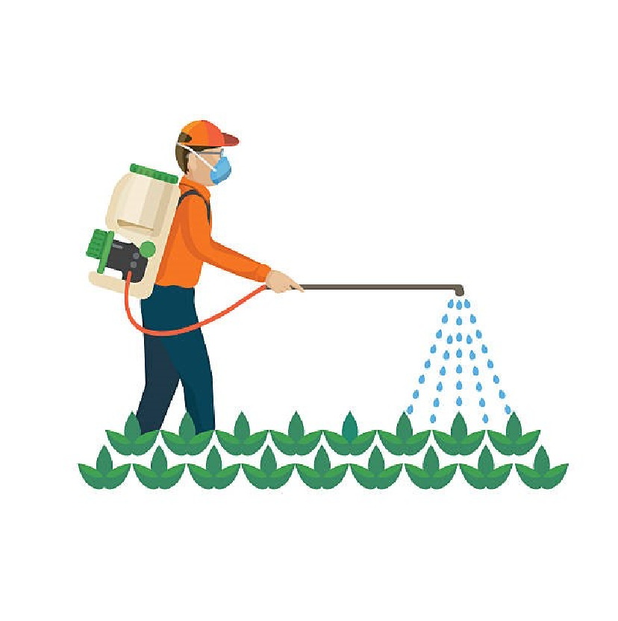
Glyphosate Most commonly known as Roundup®, this active ingredient can be found in many herbicides. Glyphosate only works on foliage. It has no soil activity. Glyphosate kills all plants, leaving bare ground for new weeds to get established, unless you plan to re-seed after spraying. Use caution when using Glyphosate!
Clopyralid This chemical is commonly sold as Transline®. Although not labeled for turf, it is a great broadleaf herbicide for pastures and non-crop settings. Transline® is recommended when weeds are growing among conifer trees.
If you add 2,4-D, it is called Curtail®.
If you add Triclopyr, it is Redeem® or Confront®.
Chlorsulfuron A selective broadleaf herbicide for use in non-crop settings. It is commonly known as Telar®. Go to page 15 to find how to purchase this herbicide locally.
Metsulfuron Commonly known as Escort®, this selective-broadleaf herbicide is used for weed and brush control in pastures, rangeland and non-crop areas.
Imazapic Commonly known as Plateau®, this selective herbicide is good for controlling broadleaf weeds and some grasses.
Norflurazon Commonly known as Predict®, this selective herbicide is applied pre-emergence for the control of grasses and some broadleaf weeds.

Pendimethalin

Page
10
Notify the Weed Board of your plan for control. Leave a
message

24
-
hours a day at 509-574-2180
-
-

Commonly known as Pendulum®, this selective pre-plant, pre-emergence, and early post-emergence herbicide is used to control annual broadleaf and grass weeds such as Puncturevine.
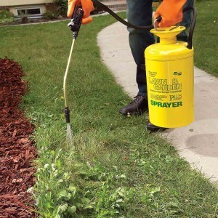
Aminopyralid
A selective broadleaf herbicide for use in non-crop settings.
It is commonly know as Milestone®. Go to page 15 to find out how to purchase this herbicide locally. It is not a restricted use herbicide, so you don’t need a license to purchase. This herbicide has systemic plus residual activity that makes it equally effective at multiple growth stages. If you add 2,4-D, it is called Forefront. If you add Metsulfuron (Escort), it is called Chaparral.

Calibrations, Conversions and Measurements
Quarts/Acr  1/2 qt./Acre =  - qt./Acre =  - qt./Acre =  - qt./Acre =  - pint/Acre =  - pints/Acre = | e to Ounces/Gallon  1/4 oz./gal.  1/2 oz./gal.  1 oz./gal.  1-1/2 oz./gal.  1/4 oz./gal.  1/2 oz./gal. | •  •  •  • | Capacity Measure Liquid  1 pint = 2 cups  1 fluid ounce = 2 tablespoons  1 cup = 8 fluid ounces  1 tablespoon = 3 teaspoons
Backpack Calibrations (Per one gallon of water)
- 2,-4D 2 ounces • Curtail 1 ounce
- Hi-Dep 2 ounces • Redeem 1 ounce
- Rangestar 1 ounce • Tordon 1/2 ounce
- Roundup 2 ounces • Milestone 2 milliliters

Good Pointers
If you are applying herbicides and are soaking the plants, your rate of application is approximately
• 100 gallons per acre.
If you are just wetting the plants, your rate of application is approximately • 50 gallons per acre.
The goal is to be applying at the 50-gallon per acre rate whenever spraying.

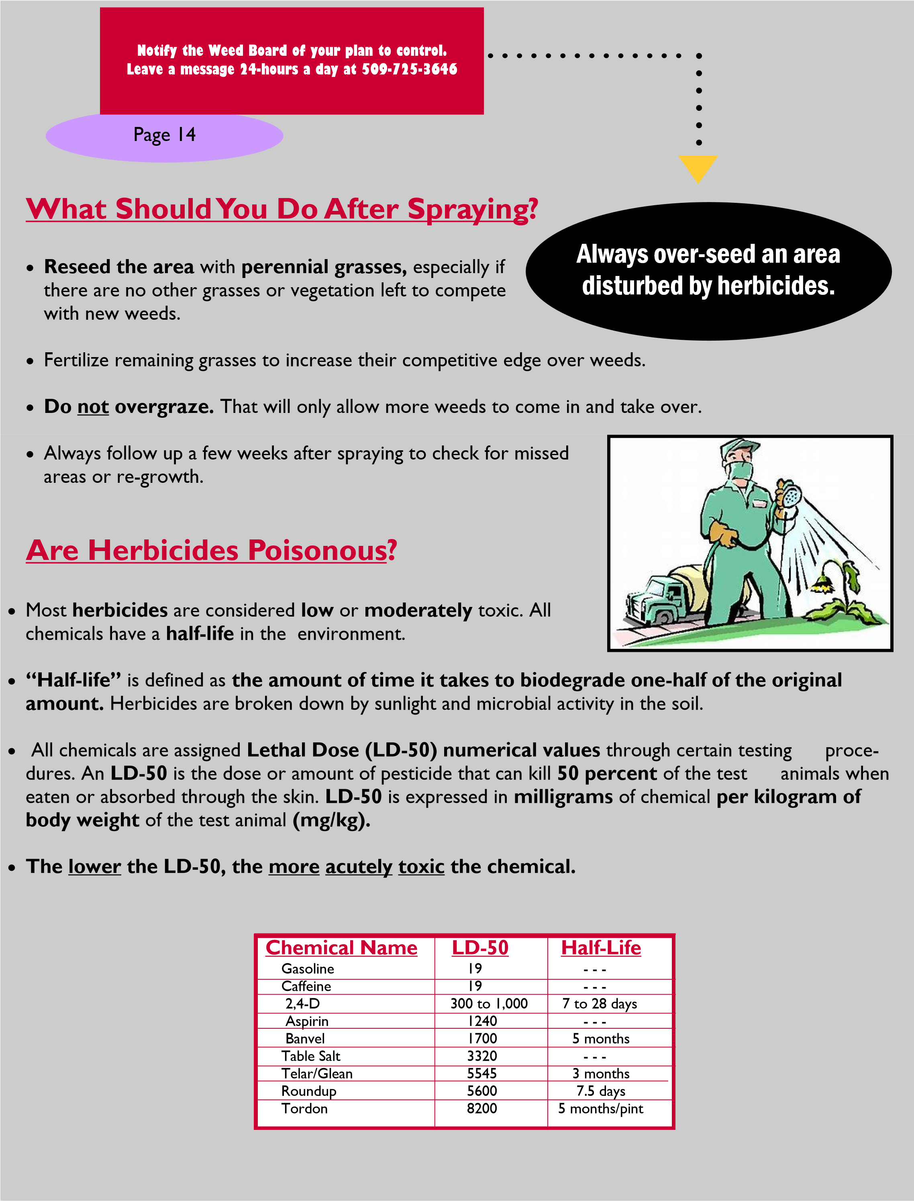
Where Do You Purchase herbicides?
- D&M Chemical 112 W Charron Rd Moxee WA 509-454-8154

- GSLong 2517 Old Town Rd, Union Gap, WA 98903 (509) 575-8382

- Wilbur-Ellis at 7 E Washington Ave, Yakima WA , 509-925-4155. The business is north of Washington Ave. East of the Railroad .

Coastal Farm and Ranch 2112 S 1st St, Yakima, WA 98903
(509) 457-2447
Yakima Co-op farm Supply 501 S Front St, Yakima, WA 98901
(509) 457-5380
Wilco Farm Supply 5801 Summitview Ave Suite A, Yakima, WA 98908 (509) 388-2500
Tractor Supply Selah: 800 N Park Dr Suite A, Selah, WA 98942
(509) 697-2000
Sunnyside: 2600 Yakima Valley Hwy Ste 1, Sunnyside, WA
98944 (509)839-0000
SEVERAL HARDWARE STORES,
Make certain you are purchasing a concentrated product, not a ready-to-spray, premixed product, and a surfactant made for herbicides.

Notify the Weed Board of your plan for control. Leave a message
24 hours a day 509-574-2180

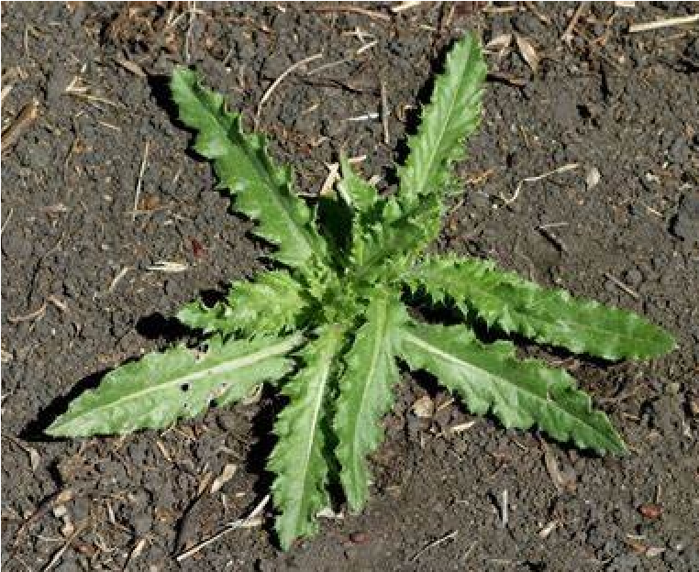
Canada Thistle needs to be sprayed with herbicide. A landowner would have effective control if the plant was sprayed in the rosette stage. Tilling and breaking up the roots will just spread the thistle throughout the field.
Scotch, Musk, and Bull thistles can be cut below the soil line 1-2 inches, to kill the root and plant; Or sprayed with herbicide and surfactant. This should be done prior to bloom. IF they are blooming, clip the buds & flowers off, bag and dispose of them.
NOTES

NOTES

